Formal Project Proposal template
Name: | Jitendra Kumar Sah
Programme: | MSc Data Science
Student ID: | 24066305
Project Title: | Analysing the impact of Inflation on Grocery Spending Habits in the UK
Problem you are seeking to address: | Persistent inflation has become a central economic challenge in the UK, particularly over the past few years. Rising consumer prices strain household budgets, impacting discretionary and essential spending patterns. This study investigates how inflation affects grocery spending behaviour, a necessary aspect of consumer expenditure critical to understanding the broader impacts of inflation on household welfare and retail sector dynamics.
Aim and scope: | This study examines the relationship between inflation trends and grocery spending habits in the UK from 2000 to 2023. Using secondary data from reputable sources, including the UK Consumer Price Inflation dataset, UK Retail Sales Pounds Data, and UK Consumer Trends dataset from Kaggle, the research seeks to quantify how changes in the Consumer Price Index (CPI) influence consumer expenditure on food and grocery products.  The scope includes integrating datasets containing monthly, quarterly, and annual measures of inflation, retail sales, and household spending in food-related categories. Control variables such as household disposable income and unemployment rate will be incorporated to isolate the effect of inflation from other macroeconomic factors. The study focuses on constructing robust time series models, applying regression analysis, and conducting diagnostic checks (multicollinearity, stationarity tests) to ensure the reliability of findings. Prior studies (e.g., Carruth, A., and Dickerson, 2003) have explored price elasticity in food sectors. Still, a gap remains in comprehensively mapping inflationary pressures onto evolving consumer grocery spending habits using merged, multi-source datasets over two decades.
Project objectives: | - Merging and cleaning three secondary datasets to produce a unified time series for analysis.  - Regression analysis measured the statistical relationship between inflation (proxied by CPI) and grocery spending.  - To control for factors such as household disposable income and unemployment in the analysis.  - To test model assumptions (stationarity, multicollinearity) and assess model fit.
Expected project outcomes: | The study is expected to yield empirical evidence on how inflation affects grocery spending patterns in the UK. The key artefact will be a statistical model that quantifies this relationship and provides a robust basis for policymakers and retail sector analysts to forecast or plan scenarios.  This analysis will contribute to a clearer understanding of consumer behaviour shifts under inflationary pressure. Specifically, the outcomes could help retailers tailor inventory strategies, aid policymakers in designing targeted support measures, and inform economists studying cost-of-living challenges in the UK.
Brief review of relevant literature: | The existing body of literature on consumer spending and inflation provides a robust foundation for examining the effects of macroeconomic conditions on household expenditure in the United Kingdom (Onita, 2023; Buss & Wallner, 2022; Davies, 2021). A particularly valuable reference is the time-series data from the Office for National Statistics (ONS, 2023), which offers detailed historical records on UK inflation and consumer prices.  These datasets allow for a longitudinal interpretation of price fluctuations and their subsequent impact on household budgets. In addition, publicly available economic indicators from the Bank of England—such as the Consumer Price Index (CPI), interest rate trends, and monetary policy reports—provide authentic and high-frequency data essential for constructing an evidence-based quantitative analysis.  From a theoretical standpoint, Becker’s (1965) theory of time allocation serves as a critical framework to understand how households adjust both their time and financial resources across consumption categories during periods of inflation.  Complementing this, Krueger and Perri (2006) explore the dynamics of consumption inequality, revealing how households with varying income levels respond differently to inflationary pressures. Crossley and Low (2011) further contextualise these patterns by investigating the limitations and reliability of household survey data in capturing real-time changes in expenditure behaviour.  In terms of modelling approaches, Batchelor and Dua (2020) argue for the integration of alternative data sources alongside traditional forecasting techniques to enhance predictive accuracy. This methodological direction is reinforced by the econometric guidance found in Stock and Watson (2015) and Gujarati and Porter (2009), who provide comprehensive frameworks for time-series diagnostics, model fitting, and robustness checks.  These methods are critical for assessing the magnitude and significance of inflationary effects on household consumption—particularly in volatile categories such as groceries and essential retail.  Collectively, these theoretical and empirical contributions equip researchers with both the analytical tools and data reliability necessary to conduct a thorough evaluation of inflation's impact on household grocery spending in the UK.  The combination of long-term official statistics, credible economic indicators, and sound econometric modelling ensures a rigorous, policy-relevant investigation into consumer behaviour during inflationary periods.
References: | - Buss, A. and Wallner, W., 2022. How inflation is changing consumer behavior.  - Becker, G.S., 1965. A Theory of the Allocation of Time. The economic journal, 75(299), pp.493-517.  - Carruth, A. and Dickerson, A., 2003. An asymmetric error correction model of UK consumer spending. Applied Economics, 35(6), pp.619-630.  - Crossley, T.F., Fisher, P., Levell, P. and Low, H., 2023. Stimulus payments and private transfers. Economics Letters, 222, p.110944.  - Davies, R., 2021. Prices and Inflation in the UK-: A New Dataset. Centre for Economic Performance, London School of Economics and Political Science.  - Gujarati, D.N., 2009. Basic econometrics.  - Krueger, D. and Perri, F., 2006. Does income inequality lead to consumption inequality? Evidence and theory. The Review of Economic Studies, 73(1), pp.163-193.  - Office for National Statistics. (2023). Consumer price inflation, UK: historical series.  - Onita, L., 2023. The squeezed middle-class consumer. Rising inflation and interest rates are eating into the spending power of a historically influential demographic group, but younger members are feeling more of the impact than older ones. The Financial Times, pp.13-13.  - Stock, J.H. and Watson, M.W., 2015. Introduction to econometrics (Vol. 3, pp. 165-167). London: Pearson.
Testing and Evaluation: | The study will thoroughly inspect descriptive statistics to identify patterns, outliers, and potential data quality issues in the merged datasets. Stationarity in the time series data will be rigorously tested using the Augmented Dickey-Fuller (ADF) test at various lags, with p-values below 0.05 indicating rejection of the unit root hypothesis. Multicollinearity will be checked using the Variance Inflation Factor (VIF), where values above five will prompt model adjustments, such as removing or transforming variables. Model residuals will be examined using the Durbin-Watson test and visualized through autocorrelation and partial autocorrelation function (ACF and PACF) plots to detect autocorrelation. Normality of residuals will be evaluated using histogram plots and statistical tests such as the Jarque-Bera test. Model fit will be assessed using Adjusted R-squared, Akaike Information Criterion (AIC), and Bayesian Information Criterion (BIC). Robustness will be tested by altering the model specification, using different subsets of data, adding lagged variables, and comparing results across alternative regression approaches. Further, sensitivity analyses will include checking the impact of structural breaks or outliers on the model results. Diagnostic plots will accompany each regression output to visually interpret relationships and verify assumptions. This extensive testing strategy will provide confidence in the empirical results and identify potential areas for future research or methodological improvement.
Ethical considerations: | This research study employs publicly available secondary data that do not comprise personal or identifiable data. Hence, it is not subject to the ethical issues of data privacy or consent. There will be no primary data collection.
Project plan: | 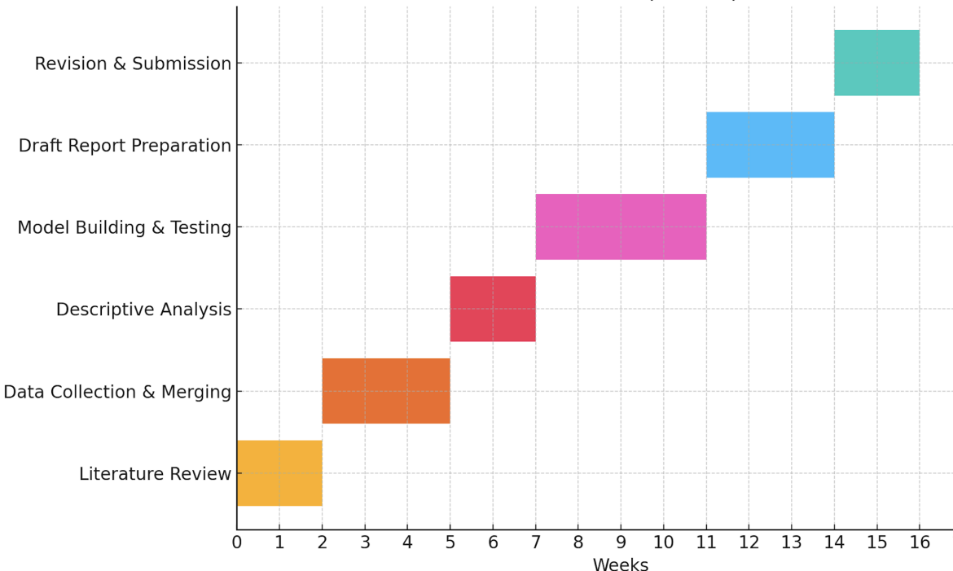.
Signature: | Jitendra

